**Online Examination System**

**Submitted by:**

* Md. Ismail Rahman
* Uttam Kumar
* Shiuly Barua
* Smriti Devi

**Introduction:**

To justify a person’s quality or knowledge examination is mandatory. Examination evaluates that, is the person capable to handle or forward or do something that’s why, examination must be clear and incorruptible. From past to present, examination is taken in analogue system such as writing papers in exam sheet or filling OMR sheet etc. Both of the examination system is costly, corruptible and have some issues like sometimes exam question gets published before examination etc. In this analogue examination system distributing exam sheets and maintaining the whole process is very troublesome. So, to get rid of these problems an online examination system is introduced in this script. This online examination system is clear, digitized and incorruptible.  This project is helpful for students to practice different mock examination online. In current generation a lot of the examination like GRE, CAT, and GMAT etc. is conducted through online exam system. This project will help students to get practice through online examination by taking mock tests from this web portal Here the whole process is maintained in server computer and managed by the client computer, so it is less troublesome. In online examination system students only need to press the radio button according to answer and press next. The system is so easy that exam controller only need to do is install the online examination system and entry the questions that’s all.

**Purpose:**

* This Web Application provides facility to conduct online examination.
* It saves time as it allows number of students to give the exam at a time and displays the results as the test gets over, so no need to wait for the result. It is automatically generated by the server.
* Administrator has a privilege to create, modify and delete the test papers and its particular questions.
* User can register, login and give the test with his specific id, and can see the results as well.
* Corporate between the data stored in the server of the Institution and our Online Exam system. To deal with Online System in an easy way and an efficient mannered. (connection process)
* Create strong and secrete data base that allow for any connection in a secret way, to prevent any outside or inside attacks.
* Specify a privilege for each person to allow each person use this system to create his own exam. And have a complete control on his exam.
* Allow each person to create more than one exam with different way to create variant questions.

**Online Examination System Feature:**

1. Login system is present and secured by password.
2. Ability to save the answer given by the candidate along with the question.
3. Answer checking system is available
4. Log out after the over.
5. Admin Panel

**Requirements:**

This project is a web application that is developed by this followings components-

1. A computer
2. Java JDK 8.0 or above
3. Database Design (Mysql)
4. Input Design (netbeans IDE)
5. Coding (java, html, jsp)
6. Server(jboss)

**Constraints:**

* User interface is only in English i.e. no other language option is available.
* User can login only with his assigned username and password i.e. no guest facility is available.
* Limited to HTTP/HTTPS.

**Specification Report**

* **System Interface**

Application would be a self-contained system. It will not access data of any other application nor will other application have access to its data.

* **User Interface**

Application will be accessed through a Browser Interface. The interface would be viewed best resolution setting. The software would be fully compatible with Microsoft Internet Explorer for version 6 and above. No user would be able to access any part of the application without logging on to the system.

**Hardware Interface**

**For Server**

• Intel Pentium III or above with

• 512 MB RAM

• 4 GB hard disk

• Network Interface

**For Client**

• PC or smart phone

• 256 MB RAM or above

• Network Interface

**Software System Attributes**

**Usability:** The links are provided for each form. The user is facilitated to view and make entries in the forms. Validations are provided in each field to avoid inconsistent or invalid entry in the databases. Some forms consists Hyper Links, which provides further details. Reports screen contains text boxes and drop down lists, so that reports can be produced.

**Security:** Application will allow only valid users to access the system. Access to any application resource will depend upon user’s designation. There are two types of users namely Administrator and Student. Security is based upon the individual user ID and Password.

**Maintainability:** The installation and operation manual of examination management system will be provided to the user.

**Availability:** System will be available around the clock except for the time required for the back-up of data.

**Portability:** The application is developed in JAVA. It would be portable to other operating system provided Struts Framework is available for the OS. As the database is made in DB2, porting the database to another database server would require some development effort.

**Acceptance Criteria**

The software should meet the functional requirement and perform the functionality effectively and efficiently.

• A user-friendly interface with proper menus.

• Data transfer should be accurate and with in a reasonable amount of time keeping in mind the network traffic.

• The system should not allow entry of duplicate key values.

• System should have the ability to generate transactional Logs to avoid any accidental loss of data.

• Log file should also be generated.

Online Examination System Model:

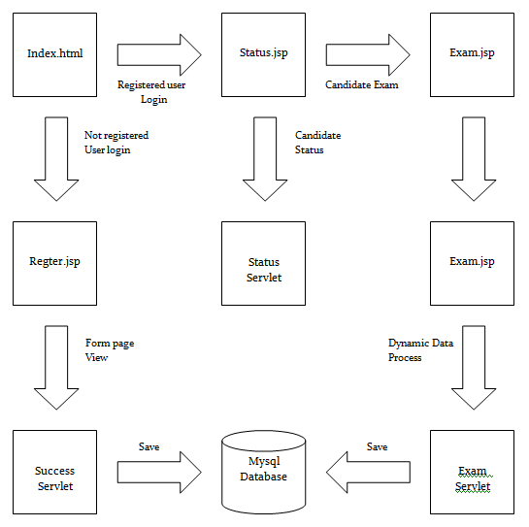

Figure: Online Examination System Model.

Program Deployment

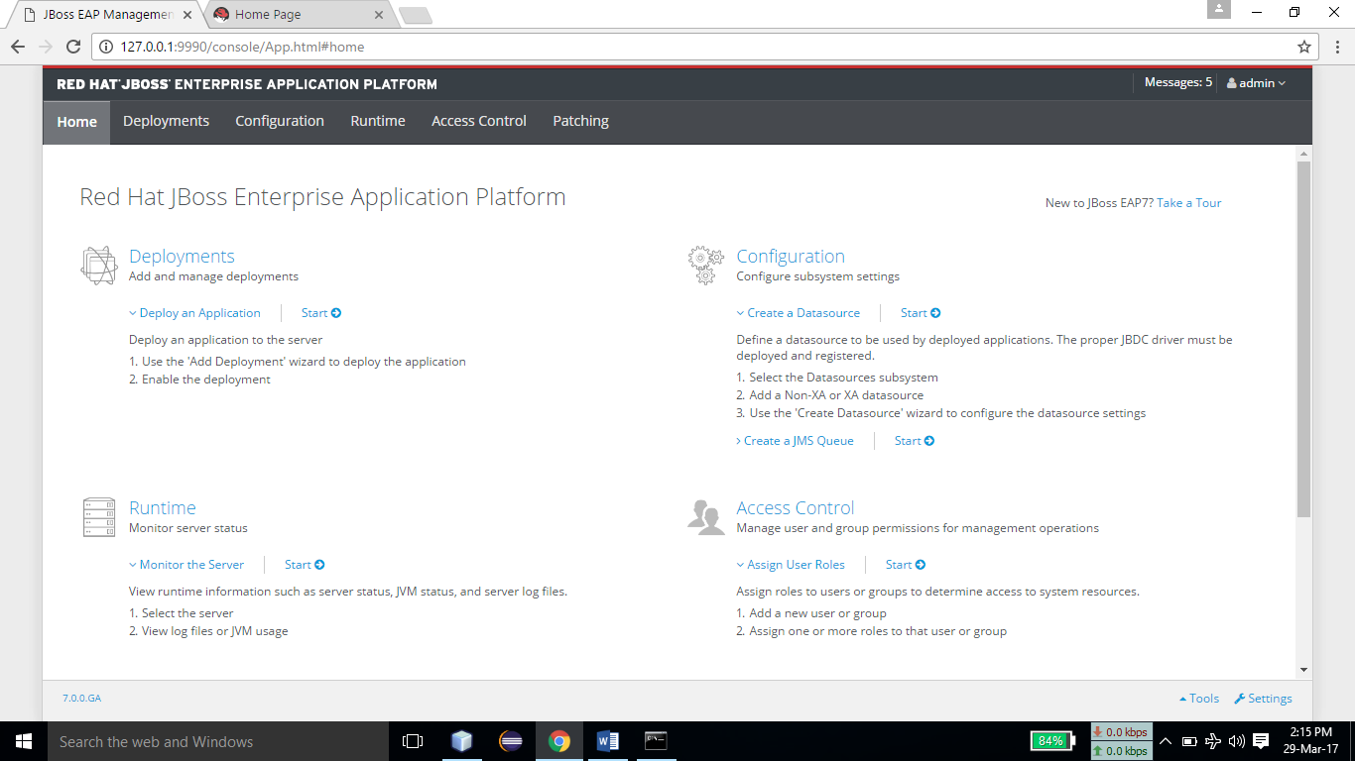

Program Deployment:

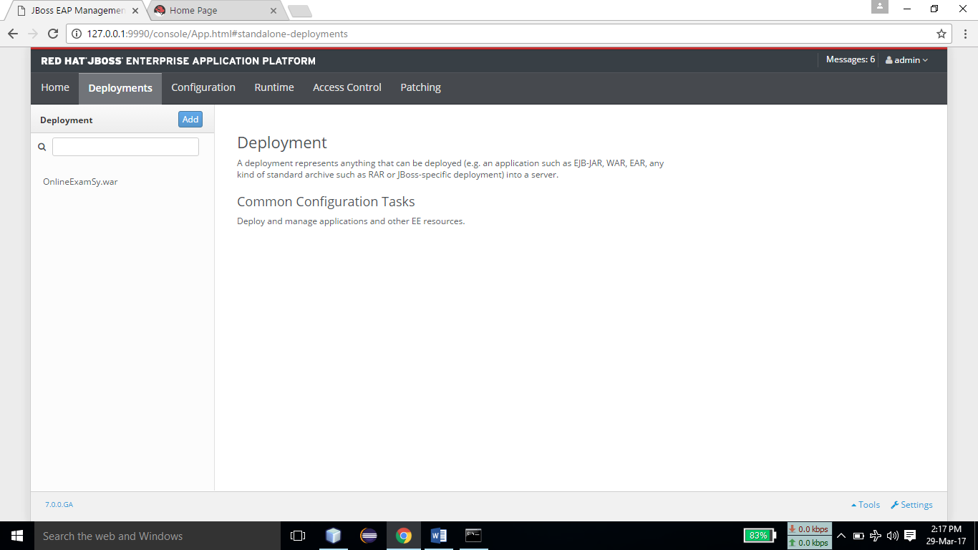

Log in Form:

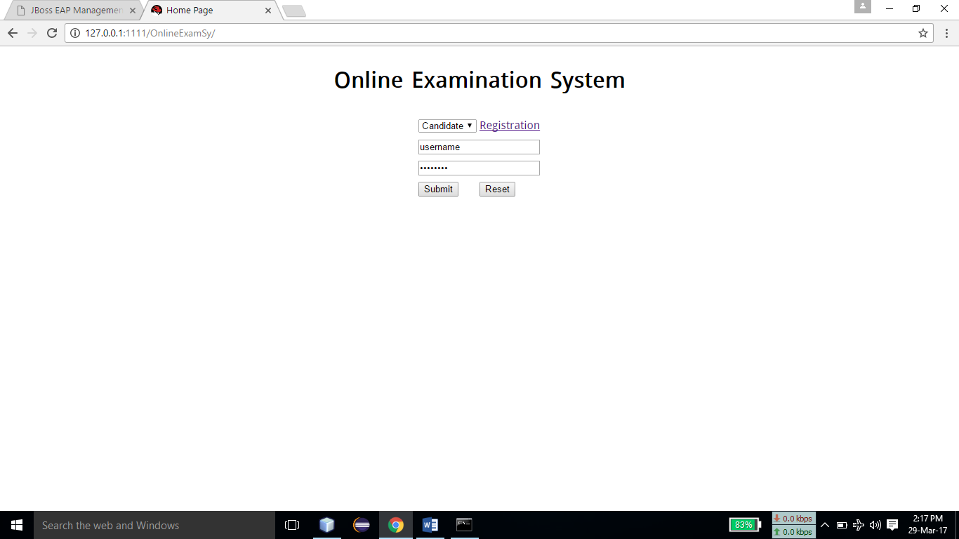

Registration Form:

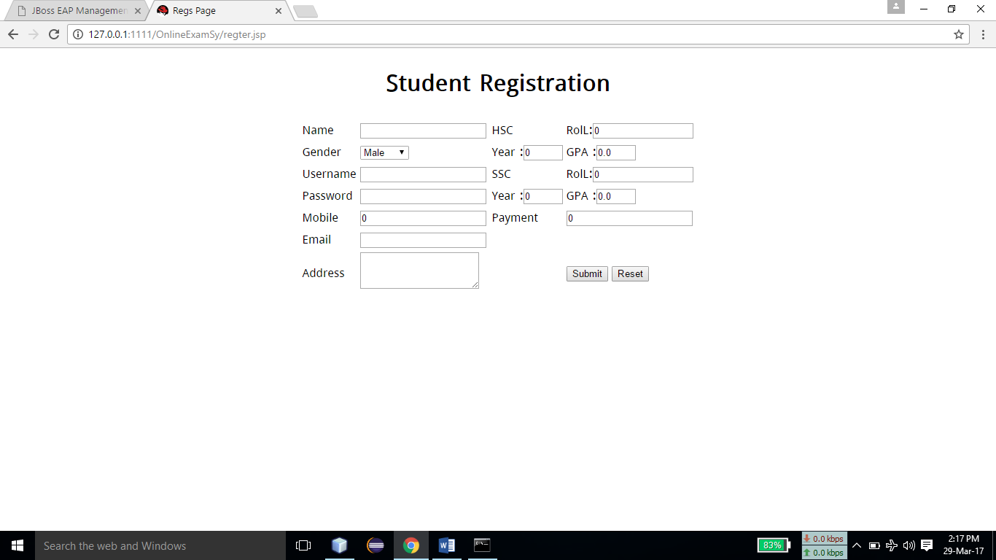

Registration Success Message:

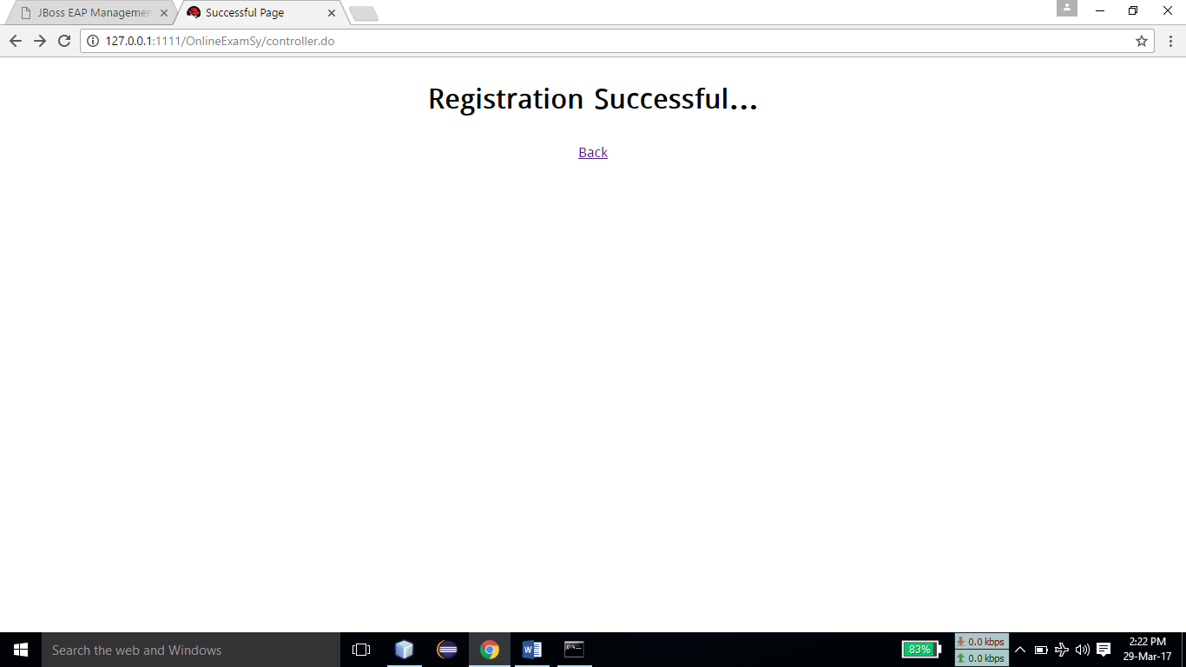

Student Information Page:

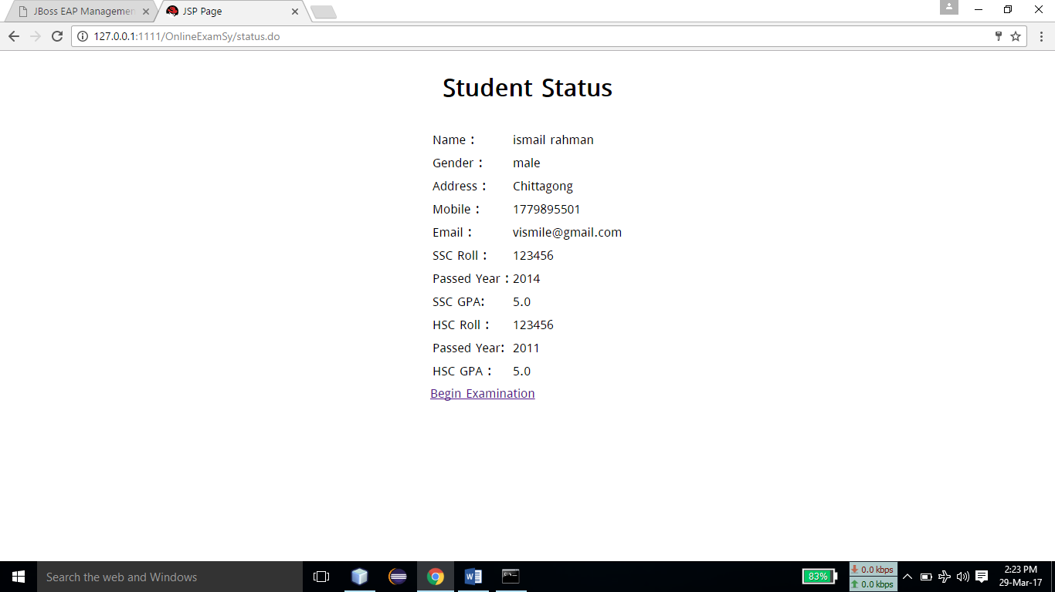

Question Form:

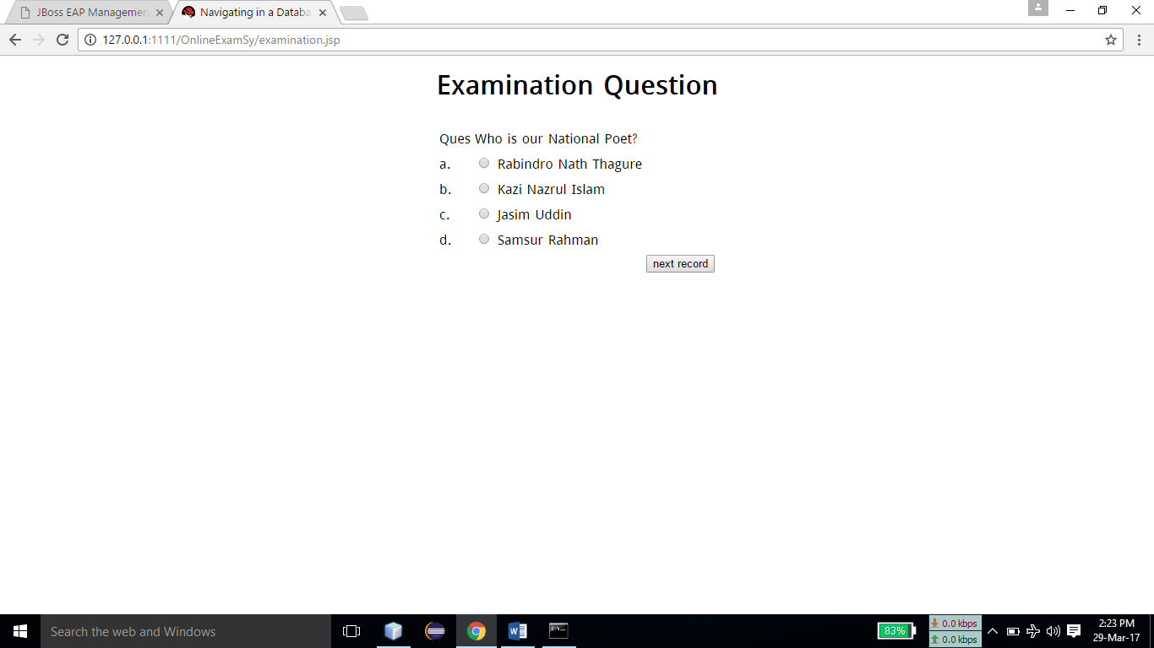

Exam Completion Page:

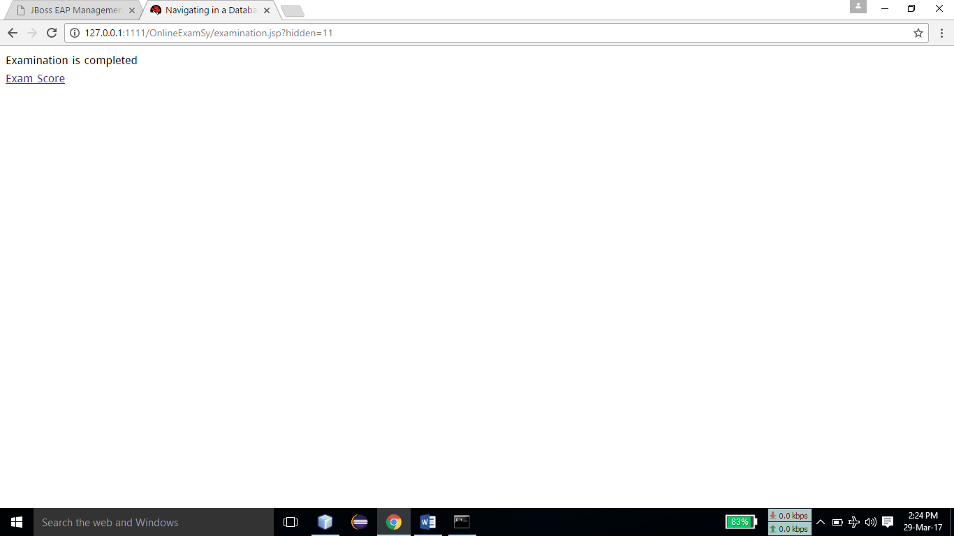

### DataBase:

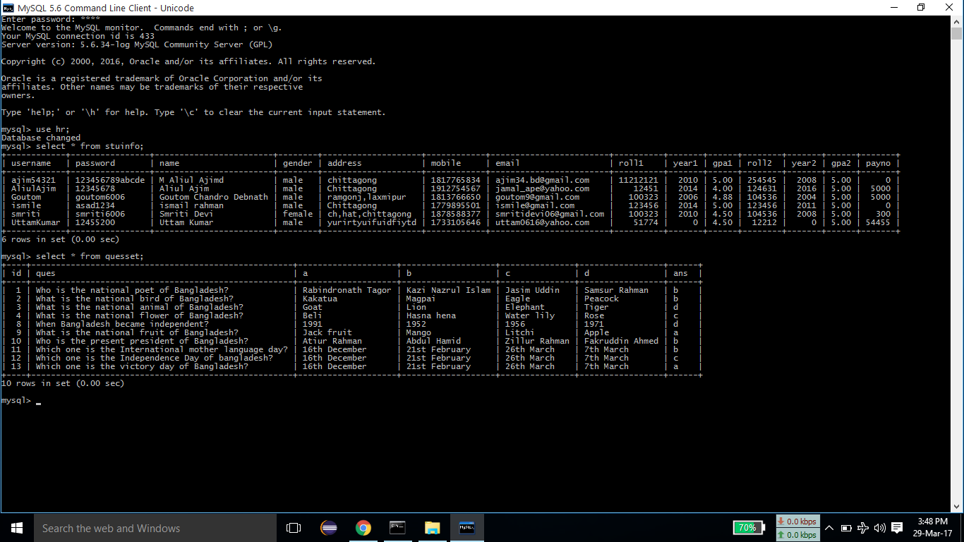

### Scope and limitations:

* On-line Exam system is designed for Educational Institutes (like schools, universities, training centers).
* The system handles all the operations, and generates reports as soon as the test is finish, that includes name, mark, time spent to solve the exam.
* Allow students to see or display his answers after the exam is finish.
* The type of questions is only multiple choice or true and false.
* On-line Exam System is very useful for Educational Institute to prepare an exam, safe the time that will take to check the paper and prepare mark sheets.
* It will help the Institute to testing of students and develop their skills.
* The disadvantages for this system, it takes a lot of times when you prepare the exam at the first time for usage.
* We need number of computers with the same number of students.

**Future planning:**

Adding ID checking and superintendence features implementation, beside the username and password, (e.g., face recognition, webcam, or finger print) included as student’s registration information that would be checked during student’s exam time.

Collecting the statistics about student results (e.g., degrees, gender, age) enables organization and researchers to do some machine learning research to improve the method of teaching, exam, and analyze the behavior of the student's learning curve, determining the standard deviation, percent of attendance, class average, issuing certificate, etc.

**Conclusion:**

As far as design is concerned no design is complete ever and there are chances of improvement each moment. However performing all the necessary testing, we will conclude that our design will implement properly that it absolutely was made.

This Web Application provides facility to conduct online examination world wide. It saves time as it allows number of students to give the exam at a time and displays the results as the test gets over, so no need to wait for the result. It is automatically generated by the server. Administrator has a privilege to create, modify and delete the test papers and its particular questions. User can register, login and give the test with his specific id, and can see the results as well.